Project Development Phase
Model Performance Test
Date | 1 October 2026
Team ID
Project Name | Import Data using Transform Maps (Spreadsheet)
Maximum Marks
Model Performance Testing:
Project team shall fill the following information in model performance testing template.
S.No. | Parameter | Screenshot / Values
1. | Data Rendered | Employee data imported from the spreadsheet is rendered in the Employee Test table (Employee ID, Employee Name, Email, Department, Location).  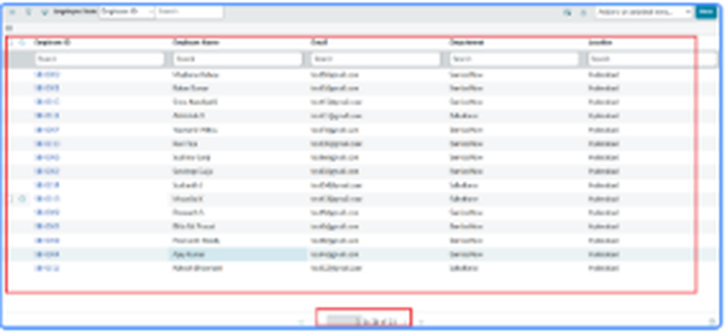
2. | Data Preprocessing | Source fields mapped to the target table using the Transform Map; Coalesce on Employee ID prevents duplicates; list columns rearranged with Personalize List Columns to validate the data.  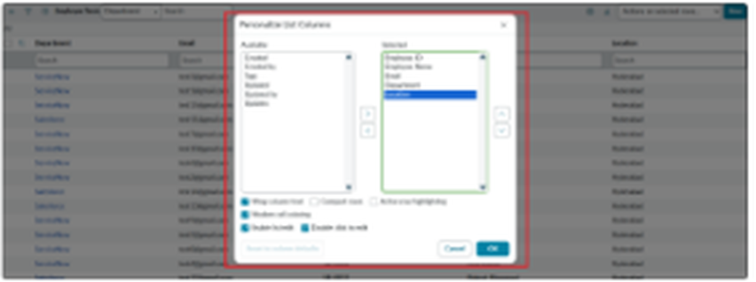  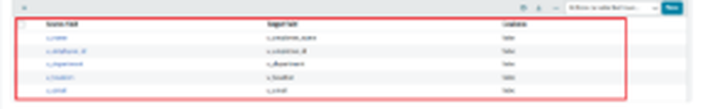
3. | Utilization of Data Filters | No separate filter conditions were applied. The report data is grouped using Group by = Department.  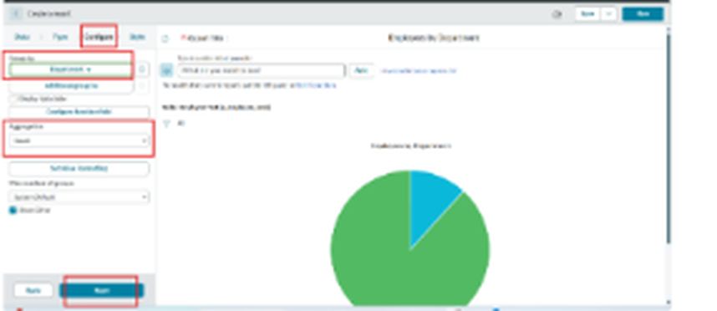
4. | DAX Queries Used | Not applicable (ServiceNow does not use DAX). The equivalent report setting is Aggregation = Count with Group by = Department.
5. | Dashboard design | No of Visualizations / Graphs - 1 (Employees by Department pie chart added to the dashboard)
6. | Report Design | No of Visualizations / Graphs - 1 (Pie chart: Employees by Department, Count of employees per Department)  